**ROAD SYMBOL CLASSIFIER**

**PROJECT REPORT**

***Submitted by***

**ANUSHA DHIMAN (2210993768)**

**ABHISHAKE BANSAL (2210993756)**

**HITESH SINGLA (2210993790)**



**BE-CSE (Artificial Intelligence)**

***Guided by***

**Dr. Tanvi Sood**

**Dr. Kanika**

**CHITKARA UNIVERSITY INSTITUTE OF ENGINEERING & TECHNOLOGY**

**CHITKARA UNIVERSITY, RAJPURA**

**NOVEMBER, 2003**

**TABLE OF CONTENTS**

1. **Acknowledgement……………….............. 03**
2. **Abstract………….………………............. 04**
3. **List of Figures…...………………............. 05**
4. **Chapters:** 
   1. **Introduction…………………... 06**
   2. **Problem Formulation………… 07**
   3. **Proposed Solution…………….. 08**
   4. **Flowchart………..…………….. 09**
   5. **Software and Hardware Requirements. 10**
   6. **Tools and Technologies used…. 11**
   7. **Code…………….. …………….. 12**
   8. **Results…………....…………….. 18**
   9. **Conclusion….…....…………….. 20**
5. **References………………..………………............. 21**

**ACKNOWLEDGMENT**

With immense pleasure, we **Ms. Anusha Dhiman, Mr. Abhishake Bansal and Mr. Hitesh Singla** are presenting “Road Symbol Classifier” project report as part of the curriculum of ‘BE-CSE (AI)’.

We extend our heartfelt gratitude to our mentors **Dr. Tanvi Sood** and **Dr. Kanika**, for their exceptional guidance, expertise, and unwavering support throughout the project. Their valuable insights, constructive feedback, and mentorship have been instrumental in shaping our project and pushing us towards excellence.

I would also like to express my gratitude towards our Dean **Dr. Sushil Narang** for giving us this great opportunity to do a project on Road Symbol Classifier. Without their support and suggestions, this project would not have been completed.

Signature……………….

Name: Anusha Dhiman Name: Abhishake Bansal

Roll No.: 2210993768 Roll No.: 2210993756

Name: Hitesh Singla

Roll No.: 2210993790

**ABSTRACT**

The Road Symbol Classifier project represents a groundbreaking initiative aimed at revolutionizing road safety and facilitating the seamless integration of autonomous vehicles. At its core, the project seeks to address the pressing need for swift and accurate recognition of traffic signs in real-time, a critical aspect in the evolving landscape of autonomous transportation. Leveraging cutting-edge machine learning methodologies, notably Convolutional Neural Networks (CNN), the project is meticulously designed to enhance the precision and efficiency of traffic sign recognition.

The primary objective of the Road Symbol Classifier project is to revolutionize road safety by developing an advanced traffic sign recognition system. Focused on the swift and precise interpretation of traffic signs in real-time, the project aims to address the crucial challenges posed by the integration of autonomous vehicles.

Technologically, the project embraces the power of CNN models, harnessing their ability to discern intricate patterns and features crucial for traffic sign interpretation. Additionally, sophisticated data augmentation techniques are employed to bolster the model's resilience and adaptability in real-world scenarios. The adoption of these advanced technologies is not merely a technical choice but a strategic one, driven by the necessity to meet the demands of an increasingly complex and automated transportation ecosystem.

Key features of the Road Symbol Classifier include real-time processing, high-precision classification, and a user-friendly interface. Real-time processing ensures timely decision-making for both human drivers and autonomous vehicles, contributing to enhanced safety on roadways. The high-precision classification is paramount in minimizing the risk of misinterpretation, a crucial factor in accident prevention. The user-friendly interface further extends the project's impact, making it accessible to a broader audience and facilitating collaboration between automated systems and human drivers.

Beyond the technical intricacies, the Road Symbol Classifier holds significant importance in its potential to contribute to road safety and reshape the trajectory of autonomous driving systems. The reduction of accidents, improved traffic management, and the seamless integration of autonomous vehicles into existing road infrastructure are among the project's overarching goals. This report delves into the methodology, technologies utilized, and the far-reaching implications of the Road Symbol Classifier in steering the future of road transportation toward unprecedented safety and efficiency.

**LIST OF FIGURES**

|  |  |  |  |
| --- | --- | --- | --- |
| S. NO. | LIST OF FIGURES | NAME | PAGE NO. |
| 1. | 1 | Flowchart | 09 |
| 2. | 2 | Code | 12 |
| 3. | 3 | Code | 12 |
| 4. | 4 | Code | 13 |
| 5. | 5 | Code | 13 |
| 6. | 6 | Code | 14 |
| 7. | 7 | Code | 14 |
| 8. | 8 | Code | 15 |
| 9. | 9 | Accuracy Trend | 15 |
| 10. | 10 | Loss Trend | 16 |
| 11. | 11 | Code | 16 |
| 12. | 12 | Code | 17 |
| 13. | 13 | Code | 17 |
| 14. | 14 | Image Classification Result 1 | 18 |
| 15. | 15 | Image Classification Result 2 | 19 |
| 16. | 16 | Image Classification Result 3 | 19 |

**4.1 INTRODUCTION**

In the realm of road safety, the pivotal role played by road symbols cannot be overstated. These unassuming symbols act as silent communicators, guiding and informing drivers to ensure a smooth and secure flow of traffic. As we stand on the brink of a technological revolution, marked by the advent of autonomous vehicles, the imperative for an efficient and accurate road symbol interpretation system has become increasingly evident.

In the evolving landscape of transportation, where advanced technologies are reshaping the way we perceive and interact with our vehicles, the integration of autonomous cars takes center stage. However, the seamless inclusion of these vehicles into our daily commutes is contingent upon their ability to comprehend and respond to the myriad road symbols they encounter. Traditional methods fall short in meeting this burgeoning demand, laying the groundwork for the inception of the Road Symbol Classifier project.

The crux of the Road Symbol Classifier project lies in its strategic response to the emerging era of autonomous driving. This project aspires not only to provide a reliable solution that aligns with the evolving needs of autonomous vehicles but also to significantly contribute to the overarching goal of enhancing road safety.

Two primary challenges stand before the project. Firstly, the system must exhibit a high degree of accuracy across a spectrum of real-world conditions. Secondly, the project addresses the time-consuming and labor-intensive process of data collection and labeling, essential for effective model training. To surmount these challenges, advanced machine learning techniques, particularly Convolutional Neural Networks (CNN), are employed. CNNs are known for their effectiveness in image recognition tasks, making them a suitable choice for the nuanced demands of road symbol interpretation.

This report embarks on a comprehensive journey through the development of the Road Symbol Classifier, peeling back the layers of its technological foundations. It explores the profound importance of road symbols in ensuring safety, especially in the context of autonomous vehicles. Moreover, it delves into the strategic strides taken to meet the demands of a future where autonomous driving becomes an integral part of our everyday lives. The Road Symbol Classifier project encapsulates not merely a technical endeavor but a pivotal step toward shaping a safer, more efficient future on our roads.

**4.2 PROBLEM FORMULATION**

Road safety stands as a paramount concern in the ever-evolving landscape of transportation. As our roadways become increasingly populated with vehicles equipped with autonomous capabilities, the importance of an advanced and reliable traffic sign recognition system cannot be overstated. The existing challenges in road safety stem from the limitations of traditional methods in effectively interpreting and responding to the multitude of road symbols that guide and inform drivers.

One of the central issues revolves around the necessity for precise and swift recognition of traffic signs, a crucial element in ensuring the safety and efficiency of our roadways. Traditional methods often struggle to keep pace with the dynamic nature of modern traffic scenarios, leading to potential hazards and inefficiencies. This gap in technology becomes particularly pronounced as we envision a future with self-driving cars seamlessly navigating our roads.

In response to these challenges, the Road Symbol Classifier project emerges as a proactive initiative. The underlying problem is twofold: firstly, the limitations of existing systems in accurately interpreting road symbols, and secondly, the impending need for a solution that aligns with the demands of an autonomous transportation landscape. Recognizing these challenges, our project endeavors to develop a robust traffic sign recognition system that not only addresses the current gaps in road safety but also anticipates the requirements posed by the integration of autonomous vehicles.

However, in undertaking this ambitious project, we are mindful of the key challenges that must be addressed. These challenges include the dynamic nature of traffic scenarios, variations in environmental conditions, and the need for a system that can adapt to diverse road infrastructure. The Road Symbol Classifier project is designed to overcome these challenges through innovative solutions that account for real-world complexities.

Our approach involves the integration of machine learning algorithms trained on extensive datasets, enabling the system to recognize and classify a wide array of road symbols accurately. Real-time processing is a key focus, ensuring that the system can respond swiftly to changing traffic scenarios. Additionally, we prioritize a user-friendly interface, acknowledging that seamless integration into existing road infrastructure requires not only technical sophistication but also practical usability.

In essence, the Road Symbol Classifier project seeks to redefine road safety by providing a comprehensive solution to the challenges posed by the evolving transportation landscape. By addressing the limitations of traditional methods and incorporating advanced technologies, our project endeavors to pave the way for a safer and more efficient future on our roadways, where autonomous vehicles coexist seamlessly with human-driven ones.

**4.3 PROPOSED SOLUTION**

1. **Advanced Machine Learning Algorithms**:

* Implemented state-of-the-art machine learning algorithms for robust traffic sign recognition.
* Trained the system on extensive datasets to ensure accurate classification of diverse road symbols.

1. **Real-time Processing:**

* Prioritize real-time processing capabilities to enable swift response to dynamic traffic scenarios.
* Implement algorithms that can adapt to changing conditions, ensuring timely interpretation of road symbols.

1. **High-Precision Classification:**
   * Developed a classification system with high precision to minimize errors in recognizing and interpreting road symbols.
   * Incorporated deep learning techniques to enhance the system's ability to distinguish between subtle variations in symbols.
2. **Adaptive to Environmental Conditions:**

* Integrated computer vision capabilities that account for variations in environmental conditions such as lighting, weather, and visibility.
* Implemented adaptive algorithms that optimize performance in diverse settings.

1. **User-Friendly Interface:**

* Designed an intuitive and user-friendly interface for seamless integration into existing road infrastructure.
* Prioritized simplicity and clarity to ensure accessibility for both autonomous vehicles and human drivers.

**4.4 FLOWCHART**

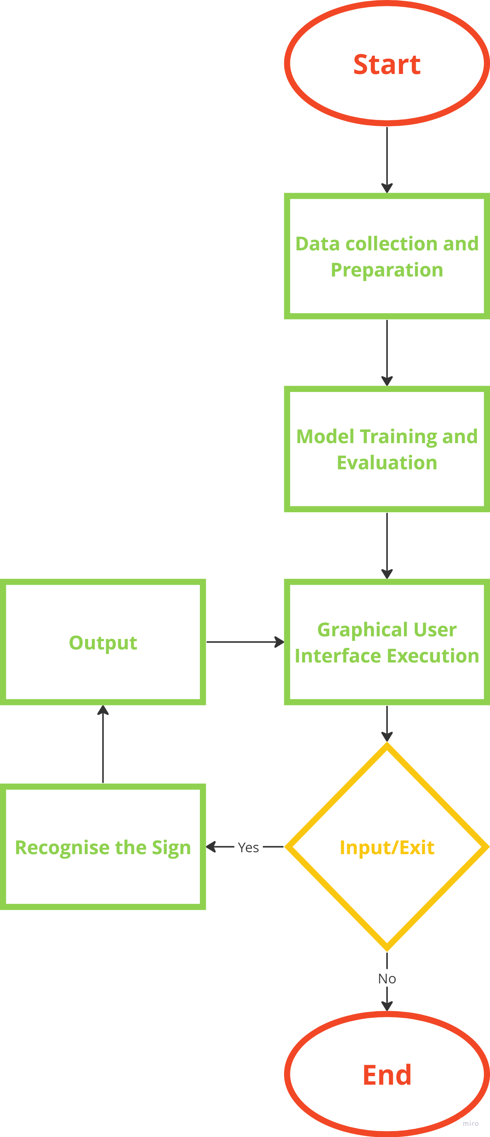

Fig. 1

**4.5 SOFTWARE, HARDWARE REQUIREMENTS**

* **Software Requirements:**

1. **Operating System:**

The Road Symbol Classifier web application is designed to be compatible with major operating systems, including Windows, macOS, and Linux.

1. **Web Browser:**

Users should have access to a modern web browser such as Google Chrome, Mozilla Firefox, Safari, or Microsoft Edge to interact seamlessly with the application.

* **Hardware Requirements:**

1. **Processor:**

The user's device should be equipped with a modern processor to handle the computational demands of the web application efficiently.

1. **Memory (RAM):**

Adequate RAM is essential for optimal performance, ensuring smooth navigation and responsiveness while interacting with the Road Symbol Classifier.

1. **Display:**

Users should have a device with a screen of sufficient size and resolution to display the application's user interface clearly.

1. **Camera:**

For real-time image capture, a device with a built-in or external camera may be necessary.

* 1. **TOOLS AND TECHNOLOGIES USED**
* **Integrated Development Environment (IDE): Visual Studio Code-** It stands out as a powerful and widely embraced source code editor, offering versatility across HTML, CSS, JavaScript, and numerous other programming languages.It offers a user friendly interface, code highlighting, debugging capabilities, and various extensions for enhanced productivity.
* **Programming Languages:**
* **Python**: Utilized for backend development, machine learning, and algorithm implementation.
* **JavaScript**: Employed for frontend development and interactive user interfaces.
* **HTML (Hypertext Markup Language):** It is a markup language used for structuring the content of web pages, defining elements like headings, paragraphs, and links.
* **CSS (Cascading Style Sheets):** CSS complements HTML by providing styling and layout instructions, enhancing the visual presentation of web content. Together, HTML and CSS form the foundational building blocks for creating visually appealing and well-structured websites.
* **Deep Learning Framework:**
* **Keras with TensorFlow Backend**: Central to the project, Keras is employed as the high-level neural networks API, using TensorFlow as its backend. This combination offers a user-friendly interface for building and training deep learning models, with TensorFlow providing a powerful and efficient execution engine.
* **Convolutional Neural Network (CNN**): Within the Keras framework, a customized CNN architecture is designed and implemented. CNNs are pivotal for image recognition tasks, making them well-suited for the accurate identification of road symbols in input images.
* **Transfer Learning**: Keras facilitates the integration of pre-trained models through transfer learning, allowing the utilization of existing neural network architectures. This accelerates training and enhances the model's ability to recognize intricate patterns in road symbols.
* **Data Visualization and Plotting:**
* **Matplotlib**: Matplotlib was employed in the generation of graphical representations for project presentations and reports. The library's customization options and support for various output formats ensured that the visualizations effectively conveyed complex information to both technical and non-technical audiences.
  1. **CODE**

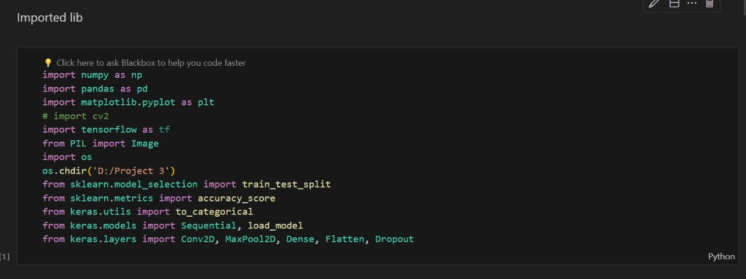

Fig. 2

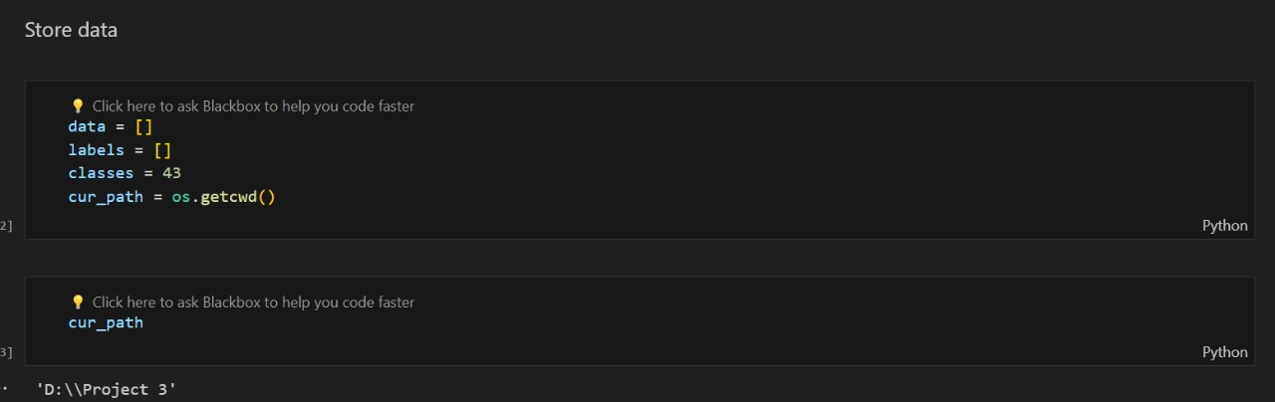

Fig. 3

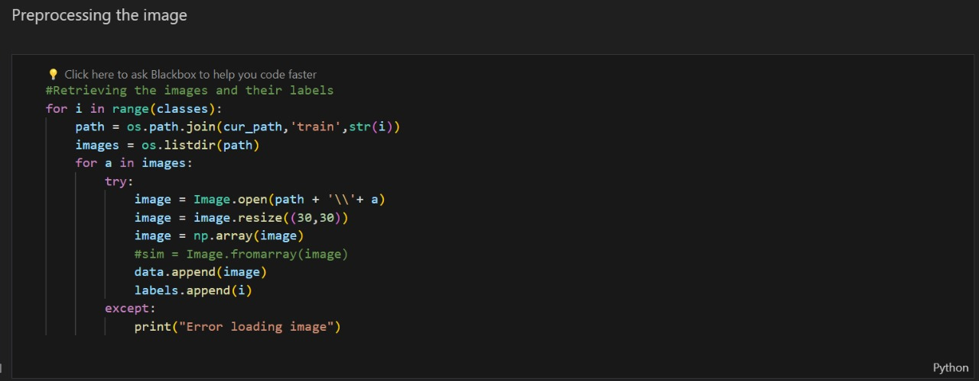

Fig. 4

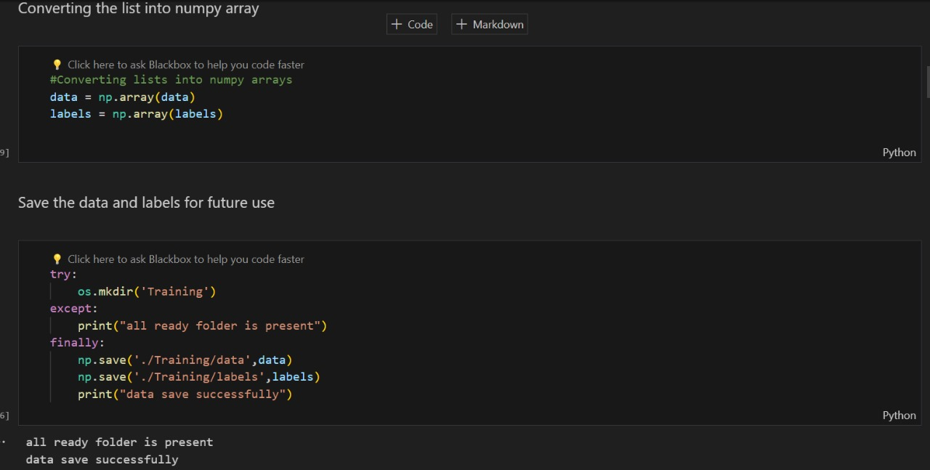

Fig. 5

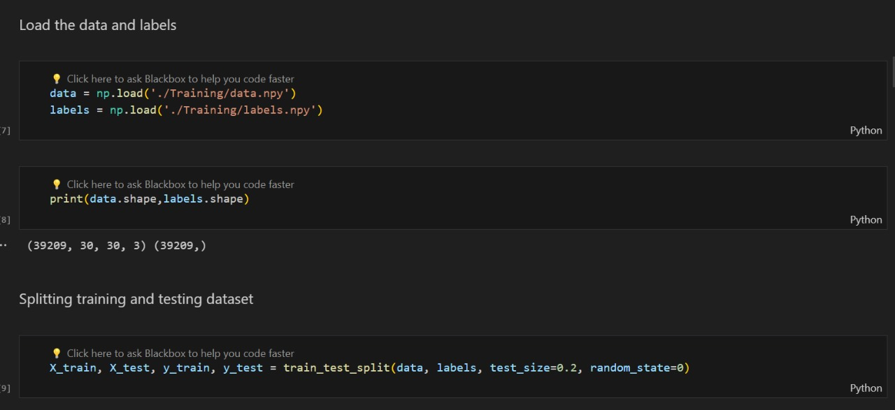

Fig. 6

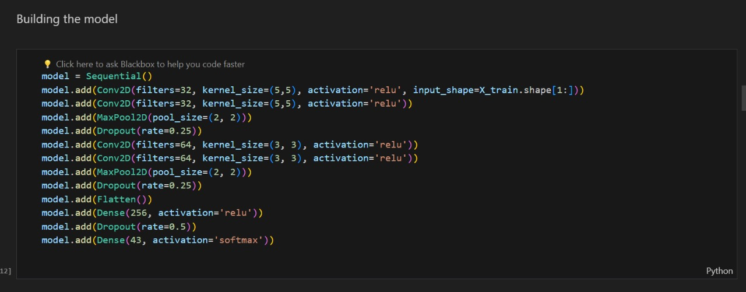

Fig. 7

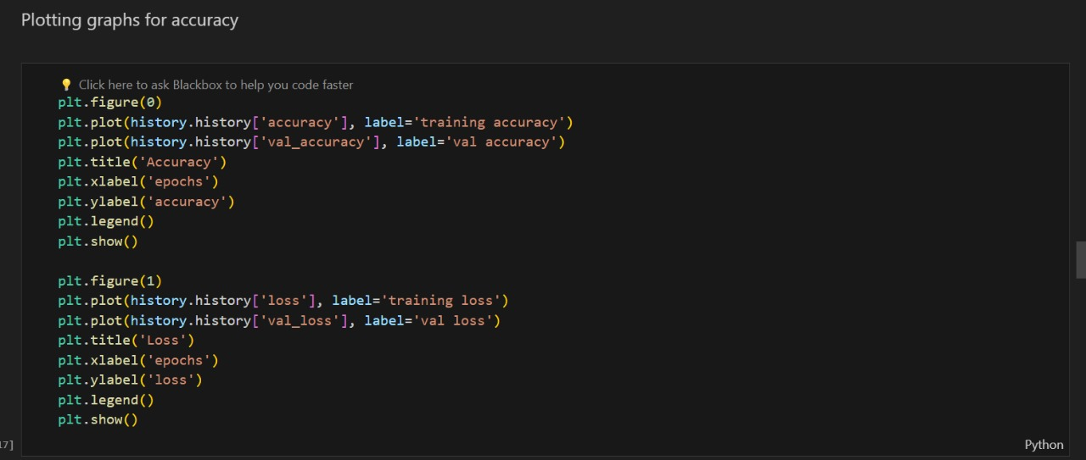

Fig. 8

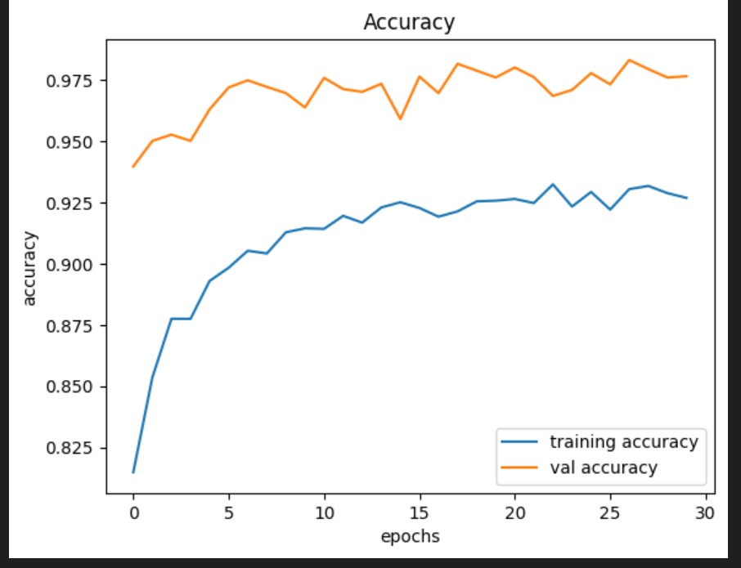

Fig. 9

Accuracy Trend

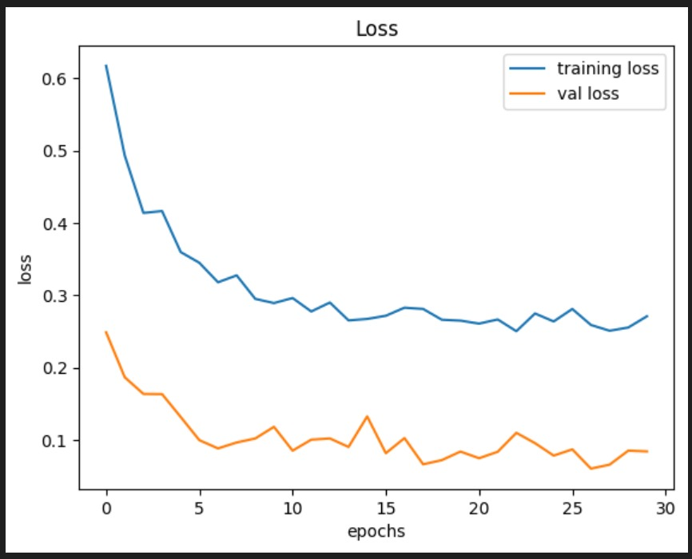

Fig. 10

Loss Trend

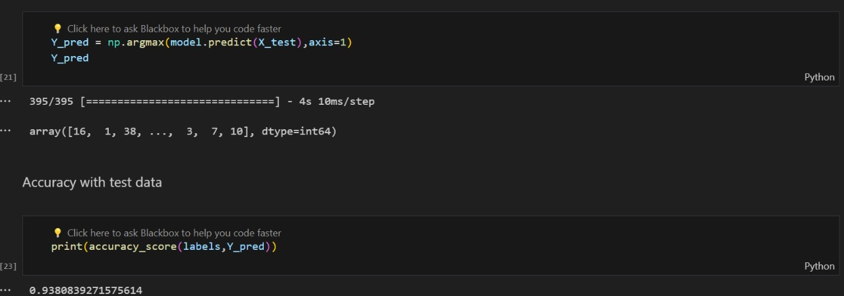

Fig. 11

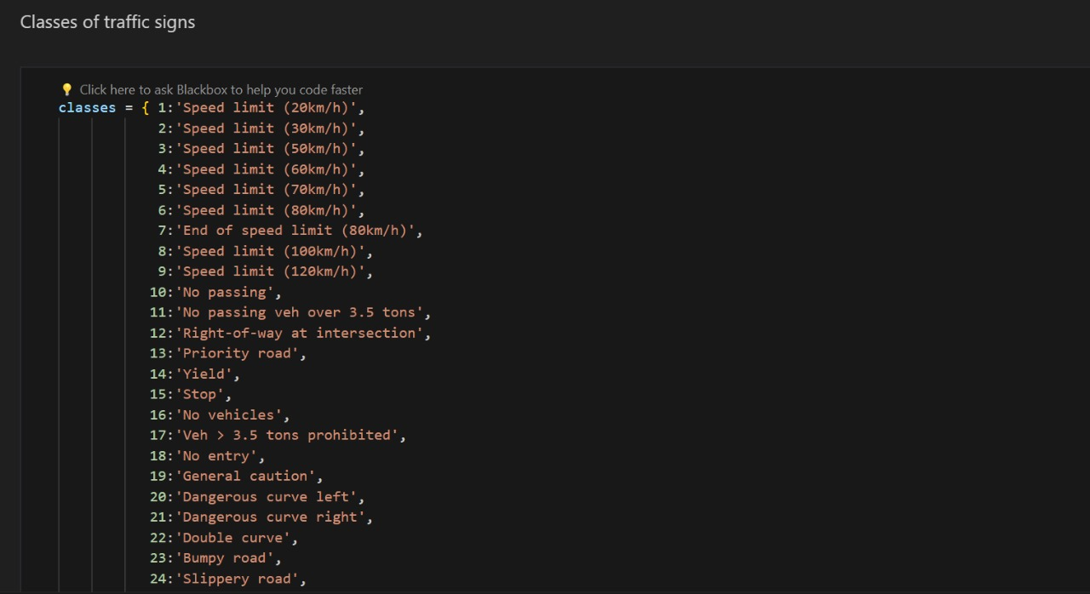

Fig. 12

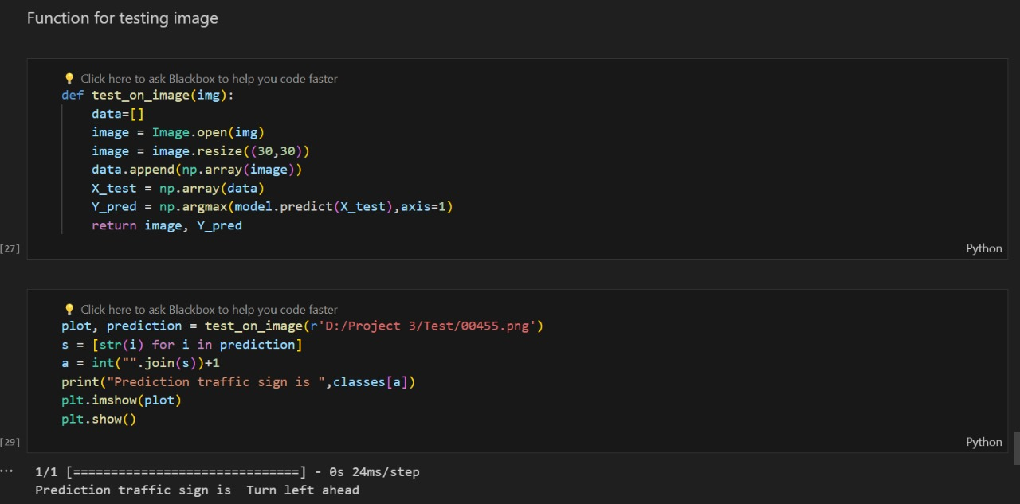

Fig. 13

**4.8 RESULTS**

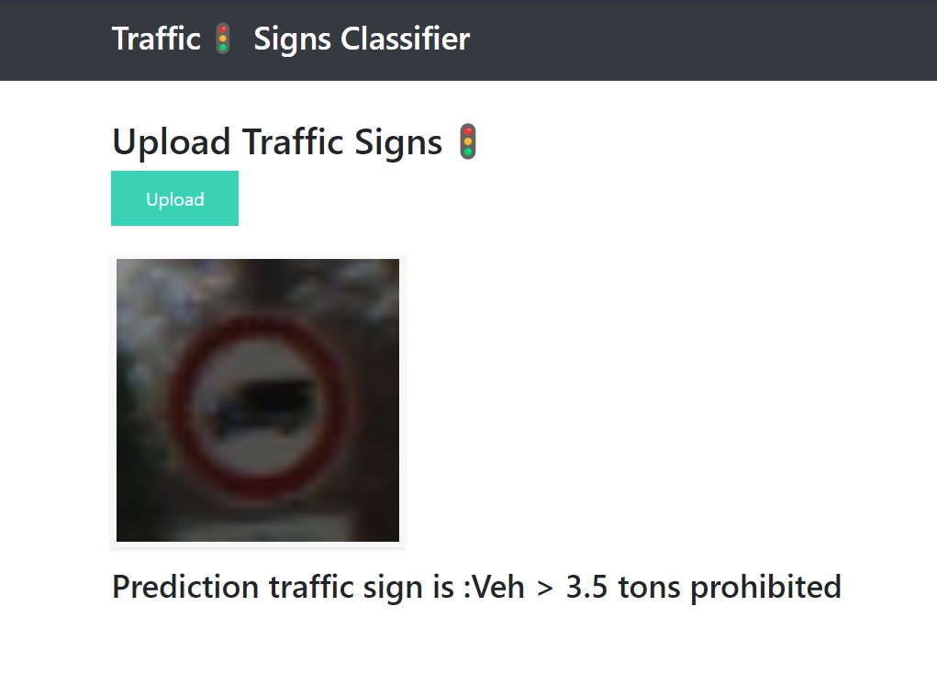

Fig. 14

Image Classification Result 1

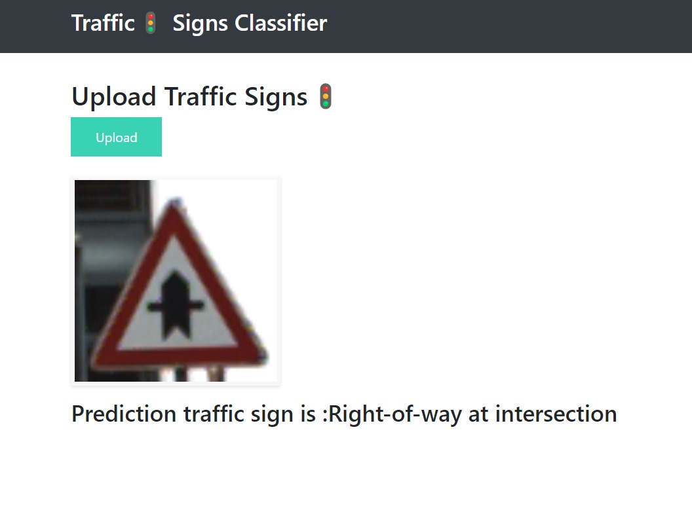

Fig. 15

Image Classification Result 2

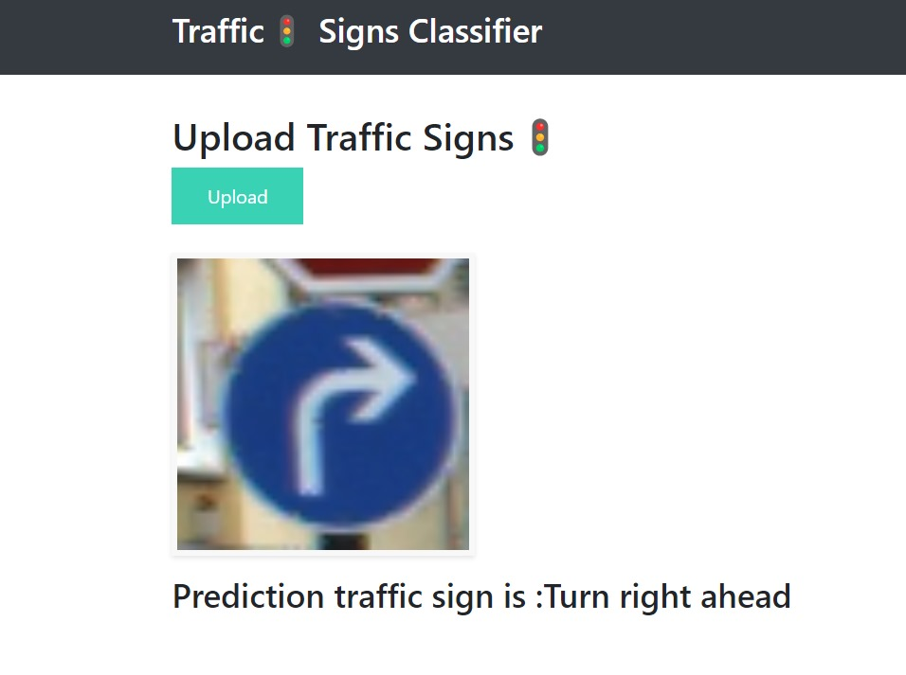

Fig. 16

Image Classification Result 3

**4.9 CONCLUSION**

In conclusion, the Road Symbol Classifier project stands as a pioneering effort in the realm of road safety, poised to revolutionize how we perceive and interact with traffic signs, especially in the context of the burgeoning era of autonomous transportation. By harnessing cutting-edge technologies such as Keras for deep learning and Flask for web development, our endeavor has been to craft a sophisticated yet user-friendly system capable of real-time interpretation of road symbols. Integrating a Convolutional Neural Network (CNN), trained on diverse datasets, significantly enhances the precision of traffic sign recognition, contributing to a safer and more efficient roadway experience.

As technology advances at an unprecedented pace, traditional methods of traffic sign recognition fall short of meeting the complexities associated with autonomous vehicles. Recognizing this gap, the Road Symbol Classifier project emerges as a forward-looking initiative, leveraging cutting-edge technologies to navigate the intricacies of traffic sign recognition. The project's impetus stems from a commitment to addressing the critical role that precise and swift traffic sign interpretation plays in guaranteeing the safety and efficiency of our roadways, especially with the escalating number of vehicles equipped with autonomous capabilities.

The primary objective of the Road Symbol Classifier is to usher in a new era of road safety by developing an advanced traffic sign recognition system capable of swift and precise interpretation in real-time. Key features, including real-time processing, high-precision classification, and a user-friendly interface underpin this vision. These features are not just technological advancements but represent a tangible contribution to the reduction of accidents, improved traffic management, and the seamless integration of autonomous vehicles into our existing road infrastructure.

The practical impact of the project extends beyond the realm of technological innovation. It envisions a future where road safety is enhanced, accidents are minimized, and the potential of autonomous vehicles is fully realized. By combining advanced technologies with a forward-thinking approach, the Road Symbol Classifier project sets a precedent for addressing the evolving demands of our transportation landscape. It is a testament to the power of interdisciplinary collaboration, where the convergence of technology, safety, and efficiency can redefine the way we navigate and interact with the roadways of tomorrow.

Looking forward, the project's success hinges on the commitment to continuous refinement, collaboration, and adaptability. As the transportation landscape evolves, the Road Symbol Classifier stands as a testament to the transformative potential of technology in ensuring the safety and efficiency of our roadways. The system not only adeptly addresses the intricacies of traffic sign recognition but also underscores the importance of leveraging advanced tools and methodologies to create solutions that align with the ever-changing demands of modern transportation.

**REFERENCES**

1. Traffic Signs Dataset- <https://www.kaggle.com/datasets/meowmeowmeowmeowmeow/gtsrb-german-traffic-sign>
2. CNN- [Convolutional Neural Networks (CNNs) - Stanford](http://cs231n.github.io/convolutional-networks/)
3. Traffic Sign Recognition Projects - <https://www.geeksforgeeks.org/traffic-signs-recognition-using-cnn-and-keras-in-python/>
4. Challenges in autonomous vehicles- <https://www.govtech.com/fs/the-6-challenges-of-autonomous-vehicles-and-how-to-overcome-them.html>
5. Research paper on Road Symbol Classifier- <https://www.sciencedirect.com/science/article/pii/S2405844022030808#sec5>
6. Book- Machine Learning by Tom M. Mitchell